
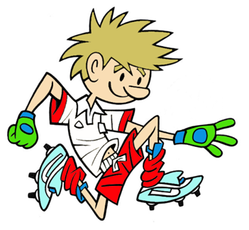

RULES - HOW TO PLAY

Pairs – 1 Ball between 2 with 2 domes

Start off in a sitting/kneeling position

Roll ball to partner through gates

Partner must return pass through gate

How many successful passes can you make in 20 secs?

FOCUS
In this activity we are developing the ability of rolling through a target with a partner.
(1 With 1 - Co-operative)
TARGET GAME: Game 2
GAME: Partner Roll
HARDER
- Stand to roll
- Make distance from partner greater
- Make gate narrower
- Run and roll through different gates to your partner
- Use hand/fist/foot/bat/hurl to aim ball through target
EASIER
- Sit closer to partner
- Make gate wider

COACHING POINTS
HEAD
- Eyes on Ball follow ball all the way into hands

HANDS – Scoop Roll
- Sending - Hands should be at back of ball with fingers pointing down when rolling
- Receiving - Scoop ball up to receive by placing backs of hands on the ground and let the ball roll up your hands into your arms

FEET
- Stand with legs shoulder width apart for Scoop Roll and one foot in front of the other for the Bowling Roll
EQUIPMENT

- Large Soft Ball between pairs

- 2 Domes for each pair

- Bats/hurls

Copyright Ulster Council GAA 2009

